Step 1: Login into **the portal.azure.com**

Step 2: Click on **SQL Database** or Select your database from the **Dashboard**

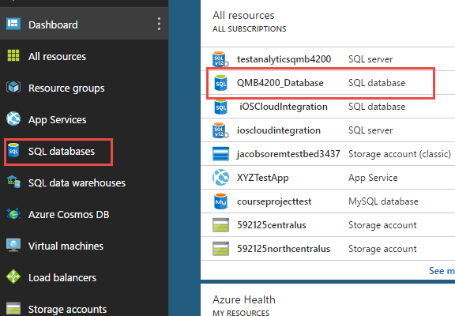

Step 3: Click **Set server firewall** tab. You need to verify if your computer IP address is added or not. If you do not see your computer IP address, then click on **Add client IP**.

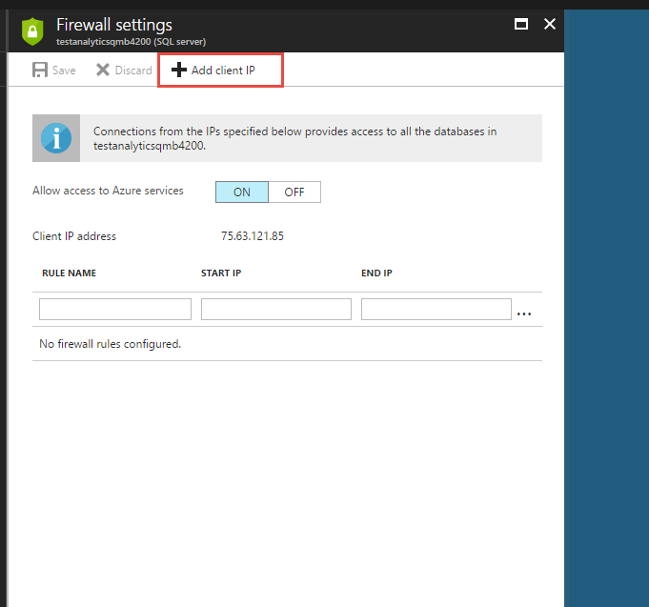

Step 4: Click **Save**

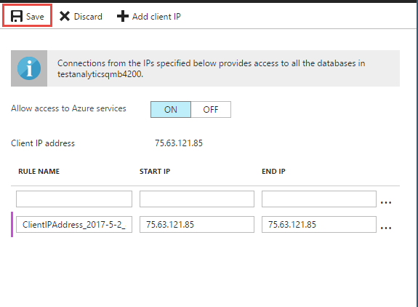

Step 5: You need to have SQL Server Management Studio on your computer to access the cloud database from your computer. You can visit below URL to install Management Studio & Data tools on your computer.

<https://docs.microsoft.com/en-us/sql/ssms/download-sql-server-management-studio-ssms>

<https://docs.microsoft.com/en-us/sql/ssdt/download-sql-server-data-tools-ssdt>

Step 6: Open SSMS on your computer and type your **database details**.

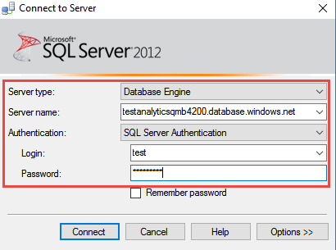

Step 7: Click **Connect and** execute the following query

CREATE TABLE CustomerAddress

(

customerName varchar(50),

CustomerID int,

CustomerAddress varchar(max)

)

Step 8: Search for **SQL Server Data Tools** on your computer and visit **File->New->Project**.

Step 9: Select **Integration Service Project, Enter name**  and Click **Ok**

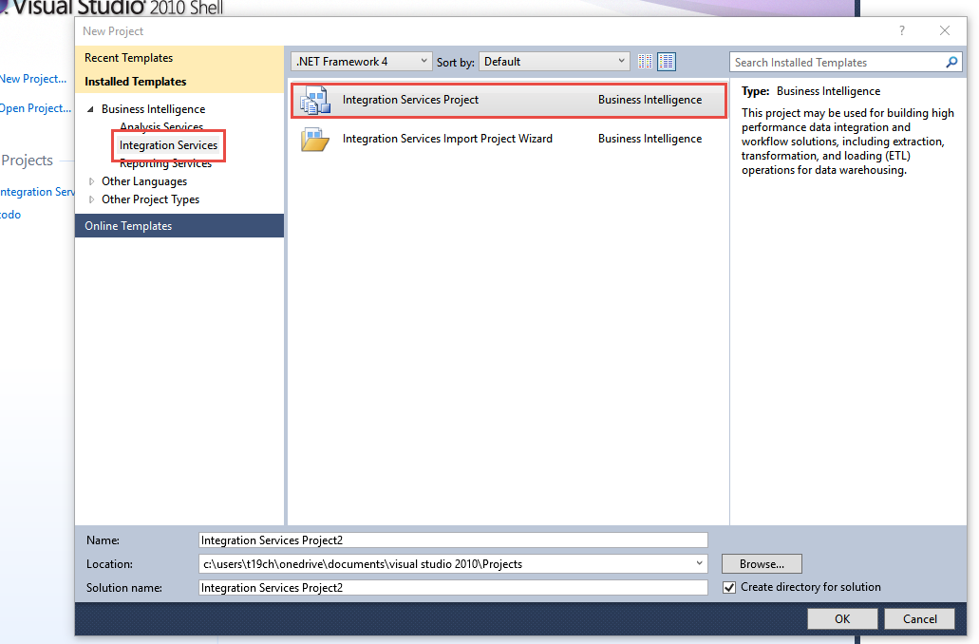

Step 10: Drag and Drop **Data Flow Task** and Click **Enter**

**Step 11: Select Source Assistant** and Configure **your CSV** path

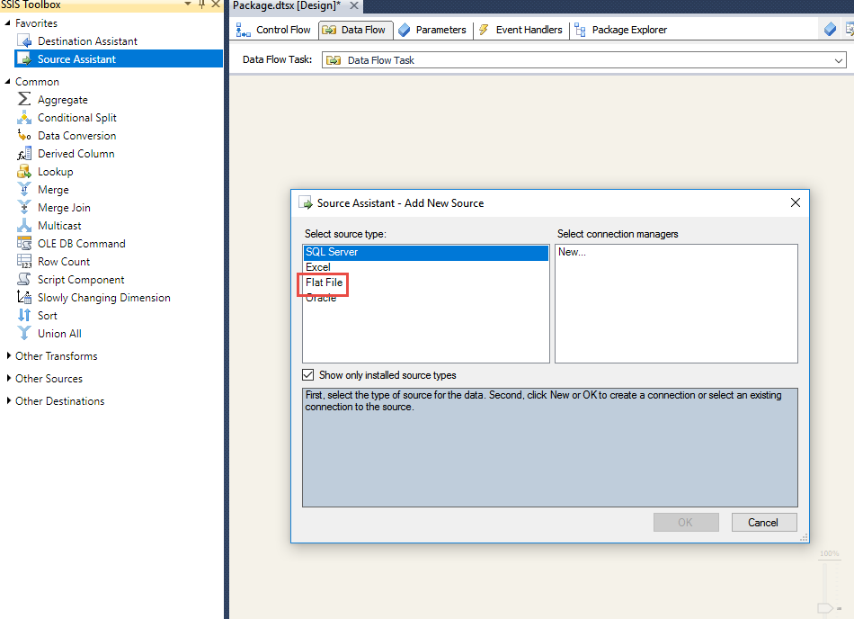

**Step 12:** Create a **new connection** and Select following parameters. Click **Ok.**

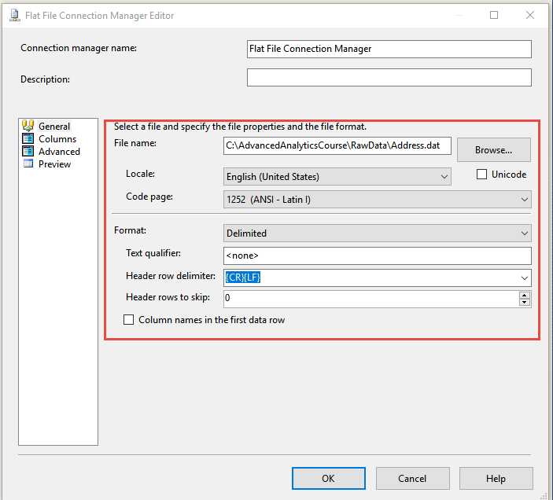

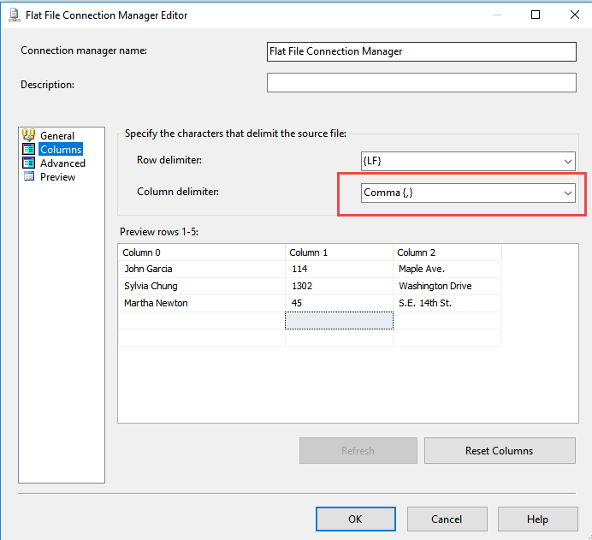

**Step 13:** Drag and Drop **Destination Assistant** and **configure SQL Azure cloud database**.

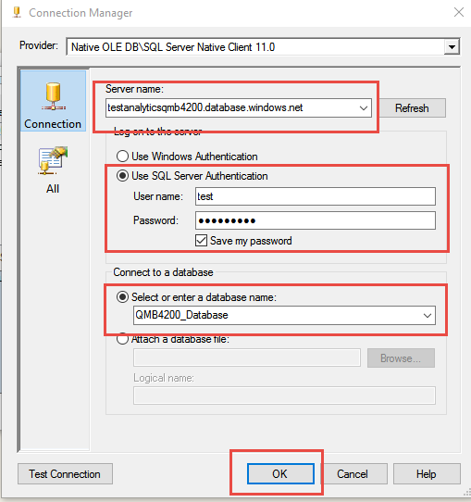

**Step 14:** Click **OLE DB Connection** and Configure **table name.** Click **Ok**

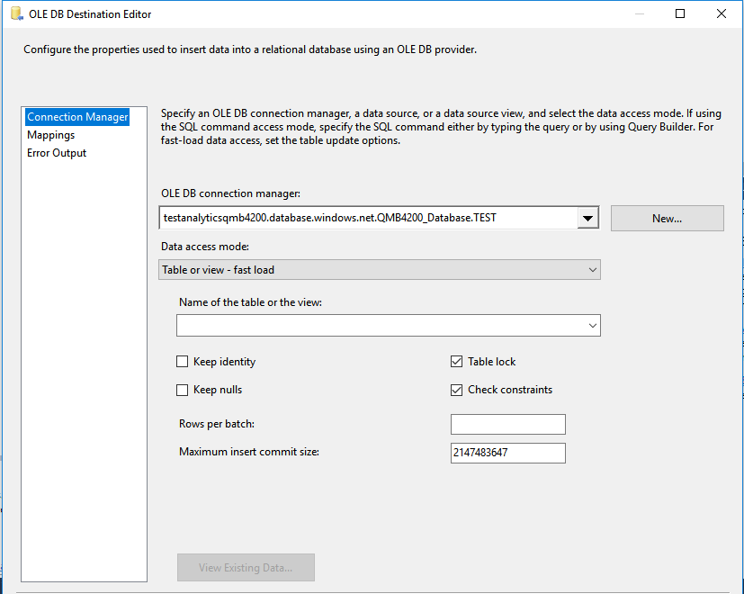

**Step 15:** Click **OLE DB Connection** and Configure **table name.** Click **Ok**

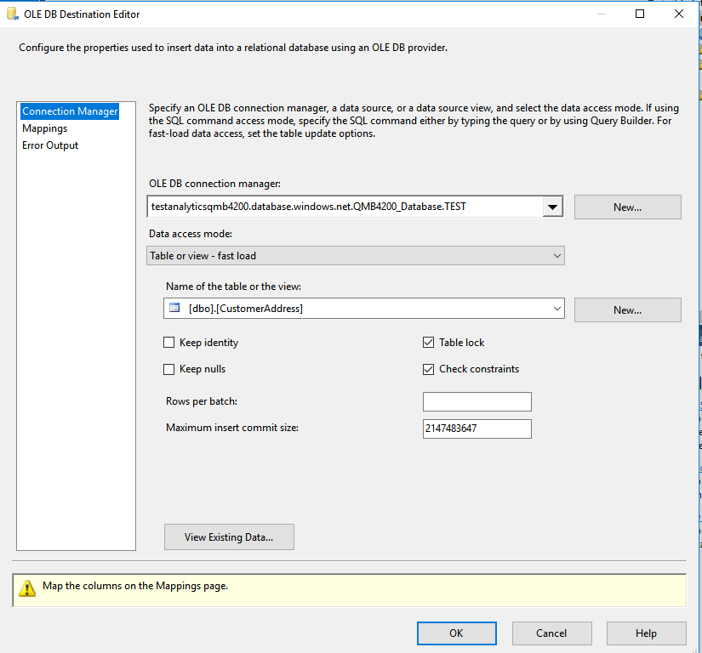

Step 16: Configure mapping with **source column** to **destination column**

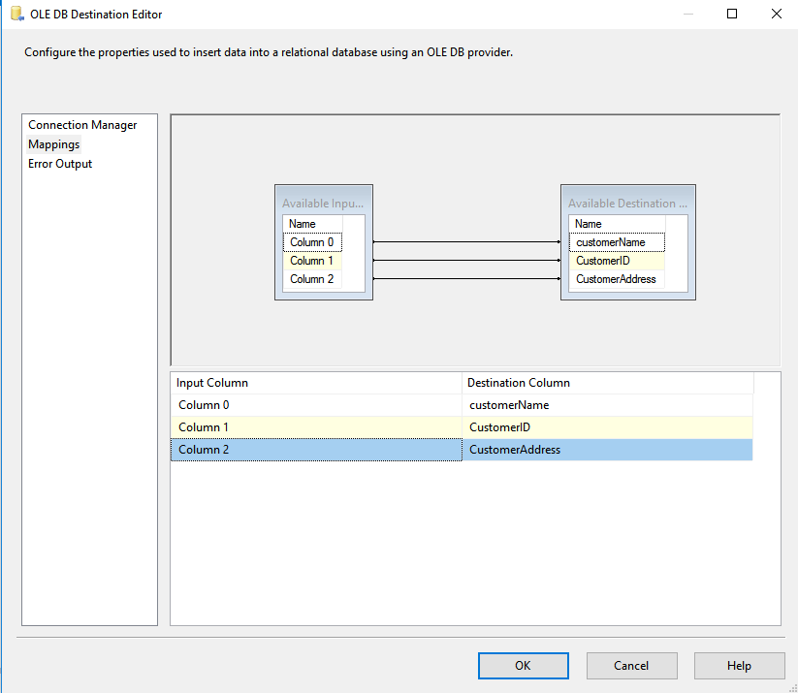

Step 17: Click **OK**

**Step 18:** Select the package and Click **Execute** button

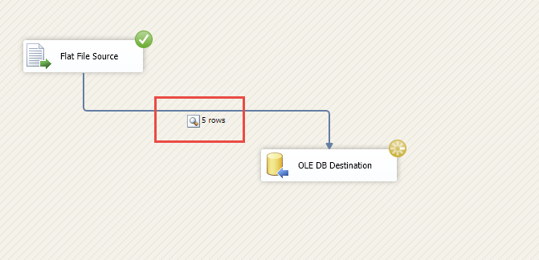

**Step 19:** Go back to Azure SQL Server and Run below query to validate data.

Select * From CustomerAddress